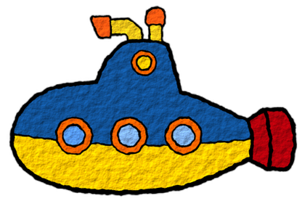
Notes from the Sub

Date: _______________________________
My Name: _______________________________________
If you have a question, you can contact me: ______________________________________________________________

Overall, class behavior: □ GREAT □ VERY GOOD □ GOOD □ MOSTLY OK □ NOT SO GREAT

Absent students: _________________________________________________________________________________________________
Tardy students: __________________________________________________________________________________________________

Star Students! ____________________________________________________________________________________________________
Students who needed reminders _______________________________________________________________________________

Assignments completed:
_____________________________________________________________________________________________________________________
_____________________________________________________________________________________________________________________
_____________________________________________________________________________________________________________________

Assignments not completed:
_____________________________________________________________________________________________________________________
_____________________________________________________________________________________________________________________
_____________________________________________________________________________________________________________________

Notes:
_____________________________________________________________________________________________________________________
_____________________________________________________________________________________________________________________
_____________________________________________________________________________________________________________________
_____________________________________________________________________________________________________________________
_____________________________________________________________________________________________________________________
_____________________________________________________________________________________________________________________
_____________________________________________________________________________________________________________________

